Cardinal Alliance Band Jacket
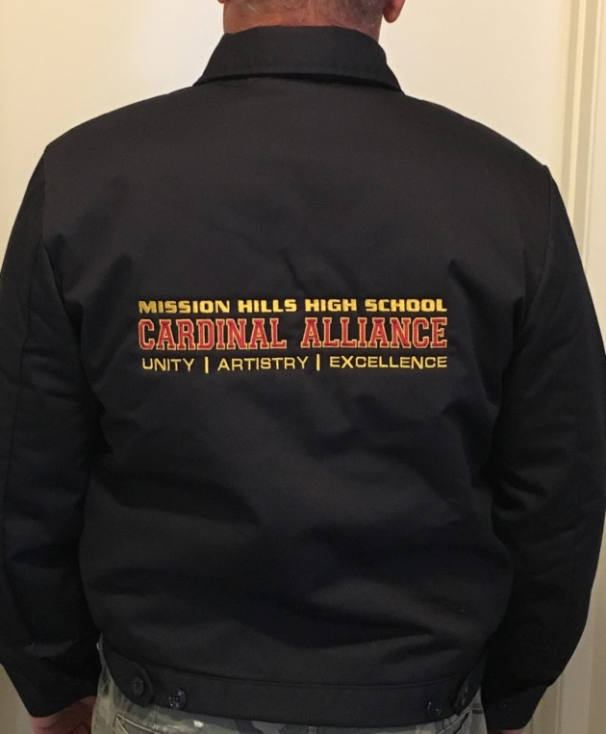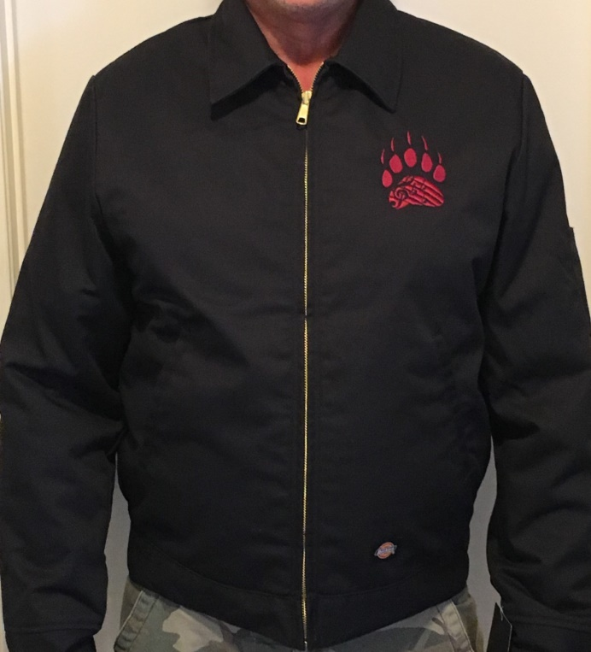
Band jackets are now available exclusively for all
Marching Band and Color Guard students
Dickies Eisenhower Insulated Jacket
• Two-piece sleeve; one-button cuff
• Lightweight warmth
- Custom embroidered logo on back
- Custom embroidered logo on jacket front
- Personalized embroidered name on jacket front optional (Additional $3)

• Generous fit across shoulders and chest
• Shell: Polyester/Cotton Twill
• Durable brass zipper front closure
• Adjustable tabs at waistband

Price: $65 (sizes XS - XL) ($68 with embroidered name)
$69 (sizes 2XL – 4XL) ($72 with embroidered name)

Please return order forms by 08/06/21 with checks made payable to:
Computer Tech Embroidery
(Please have students place order form and checks in large yellow envelope in band room marked “BAND JACKET ORDERS” by Friday, August 6th)
Student Name:_____________________________
Jacket Size: YL YXL S M L XL 2XL 3XL 4XL
First Name Embroidery: (Additional $3) ___YES ___NO Name:____________________

Please contact Alleyce Hamblin: ramblinhamblin@hotmail.com or (760) 807-7499
for more information or if you have any questions.

